# Test report

To build and compile our tests we decided to go with Travis-Ci since it is one of the most popular open source integration services that are available. Travis CI has a lot of information available about it so setting it up was easy and is running and building our system tests without any trouble. For our test runner, we decided to use Karma since it was the most adequate system to run tests for JavaScript because it is specifically designed for JavaScript testing. The testing framework that is being used with Karma is Jasmine.

Currently we are forced to do our input and output tests manually because there are technical limitations with the technologies that we are using. The Webpack system that we are implementing is conflicting with the jasmine tests and is causing the Travis builds to fail because jasmine tests do not allow a JavaScript file to contain “Import” statements.

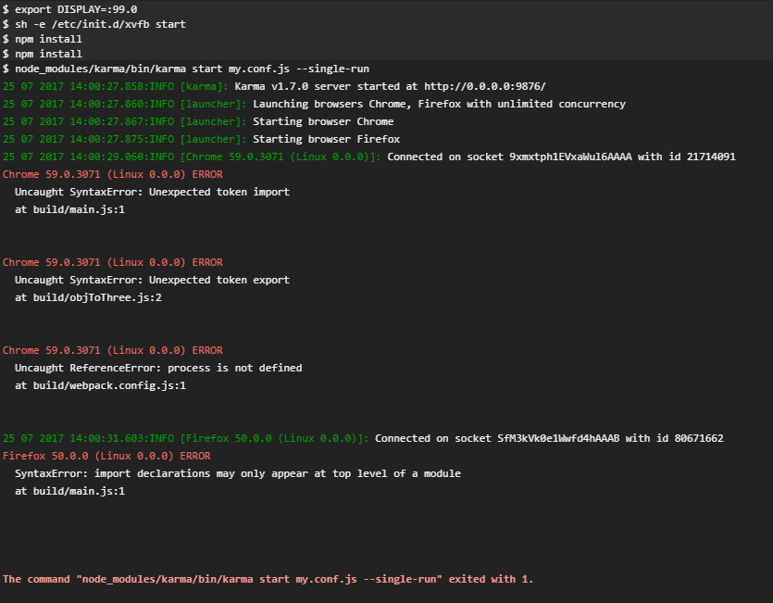

Figure : Import error

**Manual testing for converter 1:**

The Object to array converter was tested. It is supposed to take an .OBJ file as input and convert that .OBJ file’s content into an object array of colors. This test is failing because the array that is being produced does not contain the correct color values. The converter does however take the correct input.

**Manual test for converter 2:**

This converter does the array to mesh. It outputs the wireframe of the 3D object. The converter does currently take the correct input, but the converter does not test for the correct input. Hence the right error message is not displayed when the input is wrong. For now this test is failing the criteria as well and is currently under development. But although the test is failing the main goal of the converter is being achieved and it is displaying the 3D object correctly.

**Manual test for the rules applier:**

At the current stage of development this applier fails. It must receive an array and a JSON file, but the test is failing the criteria because the system is doing nothing with the JSON file yet. The JSON file is hardcoded at the moment so some changes need to be made to make the system more dynamic.

**Technical issue with Travis:**

There is currently a known issue with the Travis CI system where Travis tries to install older versions of packages and not the newly specified ones. This is the reason that we cannot fully make use of dynamic testing and we are currently working on a solution for this problem. 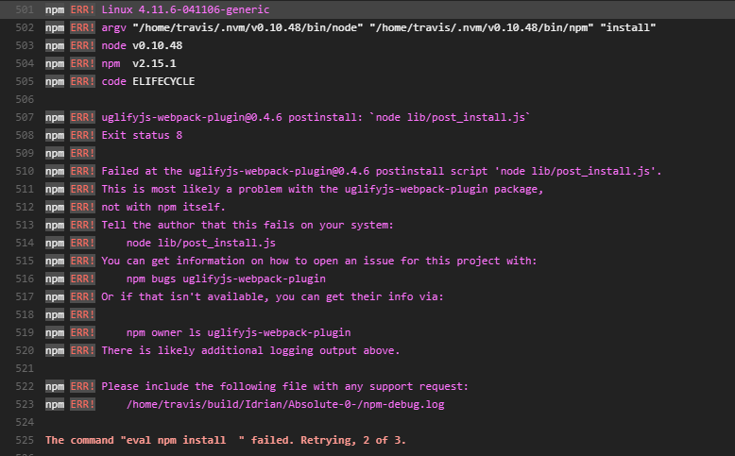

Figure : EVAL install error

## Usability testing: